**DAILY ONLINE ACTIVITIES SUMMARY**

|  |  |  |  |  |  |  |  |  |
| --- | --- | --- | --- | --- | --- | --- | --- | --- |
| **Date:** | **27-07-2020** | | | | | **Name:** | **Kanaka BS** | |
| **Sem & Sec** | **6th & A** | | | | | **USN:** | **4al17cs039** | |
| **Online Test Summary** | | | | | | | | |
| **Subject** | | **OS IA Test** | | | | | | |
| **Max. Marks** | | **30** | | **Score** | | | **-** | |
| **Certification Course Summary** | | | | | | | | |
| **Course** | **HTML CSS and JavaScript for Web developers** | | | | | | | |
| **Certificate Provider** | | | **Coursera** | | **Duration** | | | **5 Weeks** |
| **Coding Challenges** | | | | | | | | |
| **Problem Statement: Python Program for Smallest K digit number divisible by X** | | | | | | | | |
| **Status: Solved** | | | | | | | | |
| **Uploaded the report in Github** | | | | | **yes** | | | |
| **If yes Repository name** | | | | | <https://github.com/kanakabs/Daily-Status> | | | |
| **Uploaded the report in slack** | | | | | **yes** | | | |

**ONLINE COURSE**

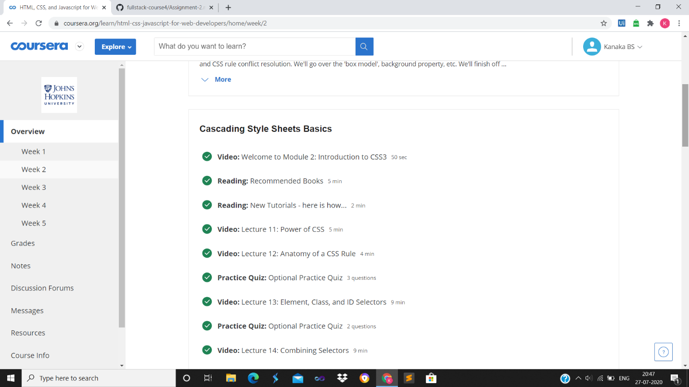

**ONLINE** **CODING**

**Python Program for Smallest K digit number divisible by X**

def answer(X, K):

MIN = pow(10, K-1)

if(MIN%X == 0):

return (MIN)

else:

return ((MIN + X) - ((MIN + X) % X))

X = 83

K = 5

print("The value is:",answer(X, K))

